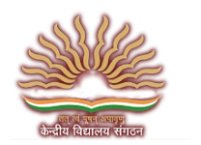

KENDRIYA VIDYALAYA, CHITTARANJAN

DEPARTMENT OF Computer science

This is to certify that the Computer Science Project on ‘**LIBRARY MANAGEMENT SYSTEM**’ has been successfully completed by **ANIKET DAS** of Class **XII (**Registration No.: ) in a partial fulfillment of curriculum of **CENTRAL BOARD OF SECONDARY EDUCATION (CBSE)** leading to the award of annual examination of the session 2015-2016.

Signature of External Examiner

Signature of Principal

Signature of Subject Teacher